Omkar Mutreja

Ananya Bhupathipalli
Mohammed Farees Patel

MAS 777 – Time Series Analysis Final Project Report

Time Series Analysis of Cryptocurrencies
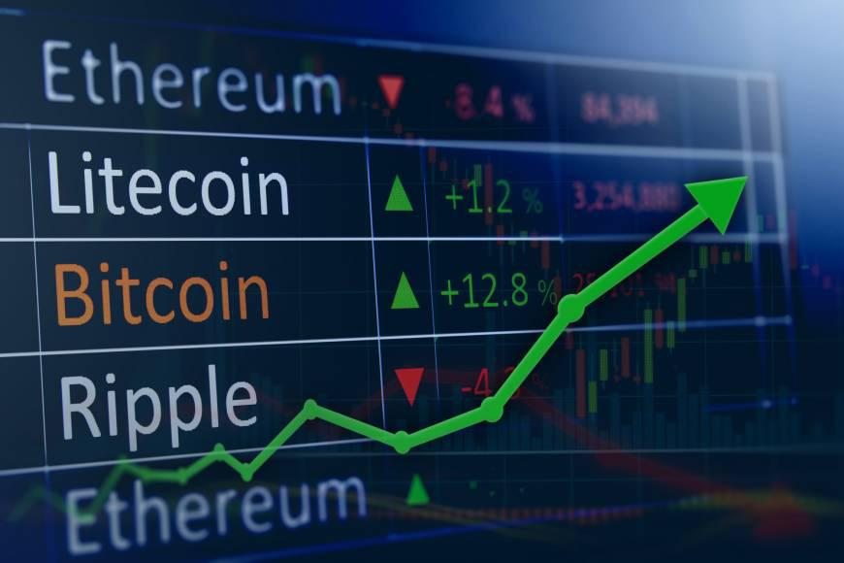
Omkar Mutreja

Ananya Bhupathipalli
Mohammed Farees Patel

Problem Statement

Blockchain and cryptocurrencies have recently created a new technology boom in the market. Bitcoin is the first decentralized cryptocurrency created in 2009. Time Series analysis of these cryptocurrencies is a new emerging area nowadays. It can help people better understand about investing in cryptocurrencies and the nature of volatility of these currencies in the coming years. Our analysis gives a deep understanding about forecasting the prices of cryptocurrencies using time series analysis. We compare several alternative univariate and multivariate models for forecasting the price of six of the most capitalized series: Bitcoin, Ethereum, Lite coin, Ripple, Dash and Monero. We compare univariate autoregressive models to univariate linear regression models based on a large set of crypto-predictors. The predictors include financial assets such as stock prices, volume and volatility. We also perform co-integration between different cryptocurrencies to see how does the price of one cryptocurrency affect others. This can help an individual to understand about trading pairs and invest accordingly.

Cryptocurrency:

The data used in this study are the cryptocurrencies prices along with volume and market cap of each currency. The data is present from 7th August 2015 to 28th February 2018 and on a daily basis. The dataset is available on Kaggle. The dataset contains information regarding 6 major cryptocurrencies.

https://www.kaggle.com/sudalairajkumar/cryptocurrencypricehistory/data

We selected 6 most popular cryptocurrencies : Bitcoin, Ethereum, Litecoin, Dash, Monero and Ripple
Omkar Mutreja

Ananya Bhupathipalli
Mohammed Farees Patel

Descriptive Statistics

Cryptocurrency | Mean CL | Min CL | Max CL | SD CL | Mean Vol | Min Vol | Max Vol
Bitcoin | 2480.2 | 210.5 | 19497.4 | 3802.252 | 1.61E+09 | 1.27E+07 | 2.38E+10
Ethereum | 147.7843 | 0.4348 | 1396.42 | 264.1308 | 5.47E+08 | 1.02E+05 | 9.22E+09
Litecoin | 32.65 | 2.63 | 358.34 | 62.08471 | 1.86E+08 | 5.08E+05 | 6.96E+09
Ripple | 0.167626 | 0.00409 | 3.38 | 0.415997 | 2.61E+08 | 2.48E+04 | 9.11E+09
Monero | 48.9525 | 0.3669 | 469.2 | 93.51828 | 26354473 | 7900 | 543884000
Dash | 146.18 | 2.06 | 1550.85 | 268.3166 | 33473725 | 18355 | 816872000

Average price of all cryptocurrencies over the years
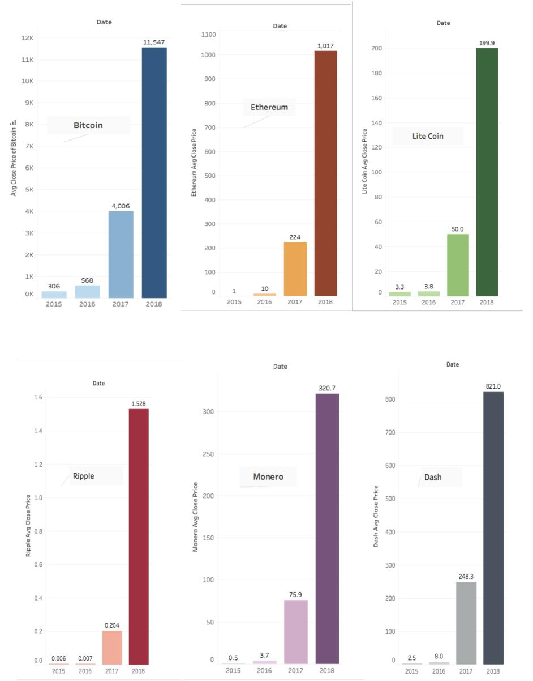
Omkar Mutreja

Ananya Bhupathipalli
Mohammed Farees Patel

Correlation Analysis

- Correlation between all the six cryptocurrencies
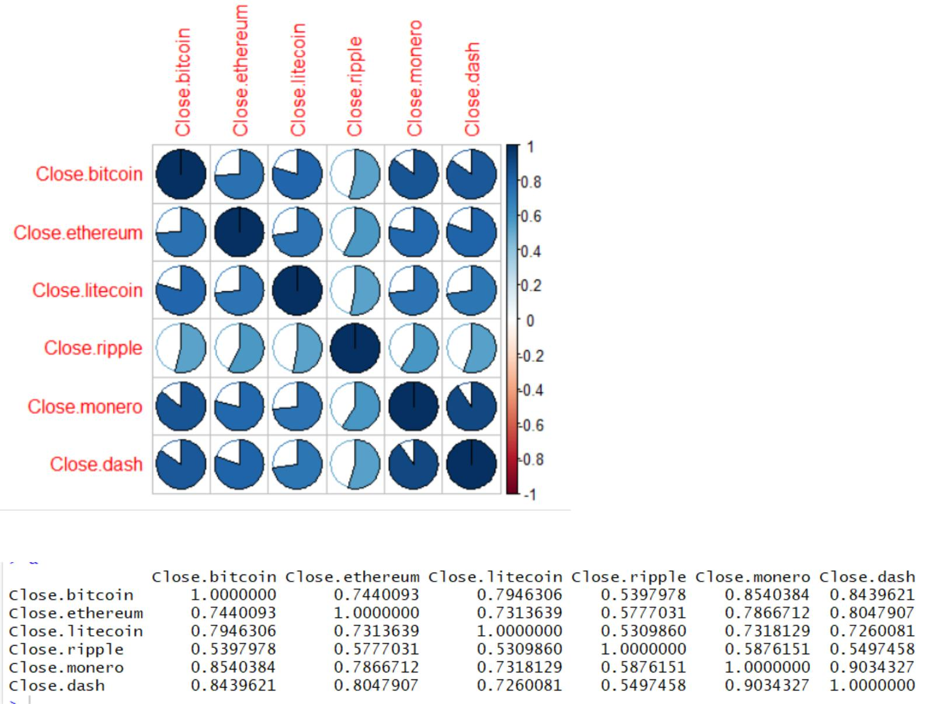

As seen from the above correlation plot and graph, there is strong correlation between all the cryptocurrencies.

Top 5 correlation pairs are:

- Monero ~ Dash = 0.903
- Monero ~ Bitcoin = 0.854
- Dash ~ Bitcoin = 0.843
- Dash ~ Ethereum = 0.804
- Lite coin ~ Bitcoin = 0.794
Omkar Mutreja

Ananya Bhupathipalli
Mohammed Farees Patel

Average Market Capital of Cryptocurrencies

Market Capital is the market value of a company’s outstanding shares. We see that “Bitcoin” has the highest market capital amongst the six cryptocurrencies and “Monero” has the lowest.

Average market capital of each of the cryptocurrencies are as follows:
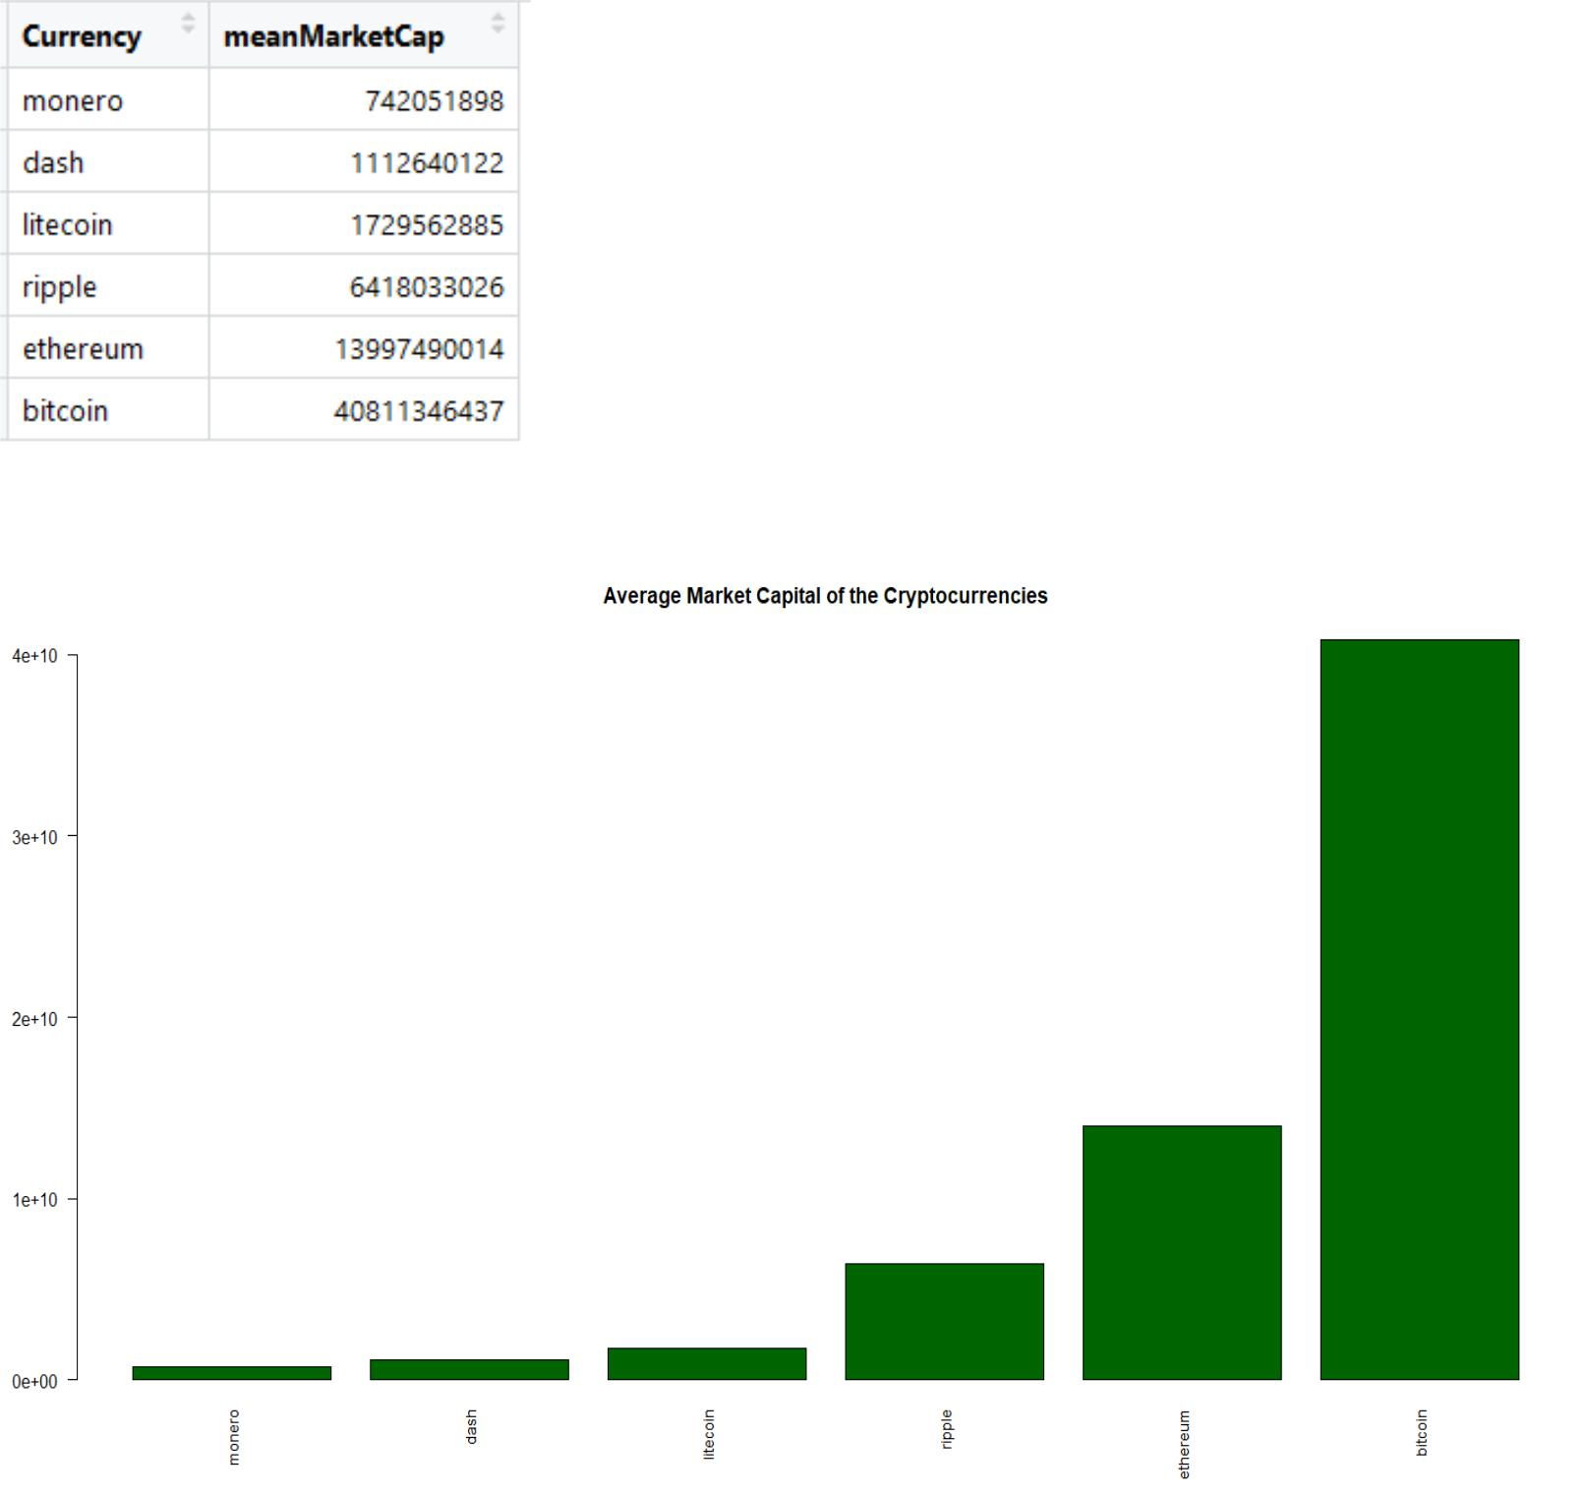
Omkar Mutreja

Ananya Bhupathipalli
Mohammed Farees Patel

Time Series Plots and Co-Integration

Below are the time series plots for each of the 6 cryptocurrencies:
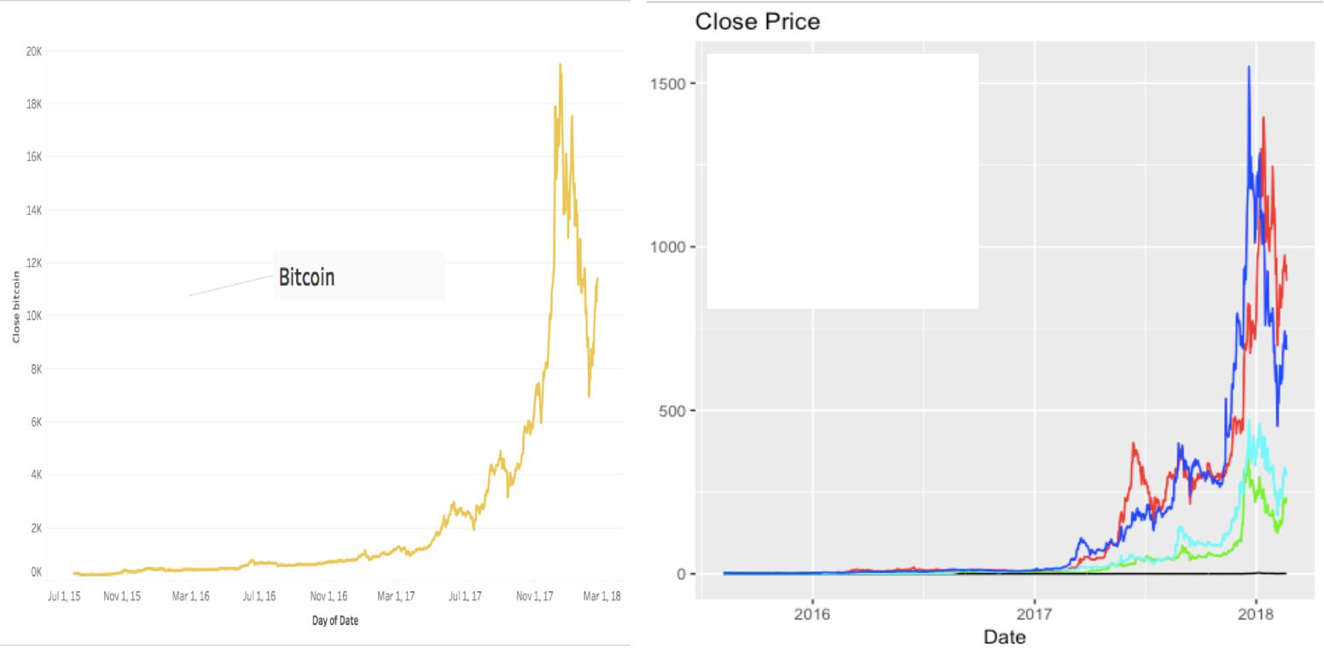

Ethereum – Red

Lite coin – Green
Ripple – Black
Monero – Cyan

Dash - Blue

As seen from the above plots, the series are non-stationary in nature. To further confirm this, we ran ADF (Augmented Dickey Fuller) test on each of these cryptocurrency series and obtained a p-value greater than 0.05, thereby proving that the series are non-stationary.

To utilize maximum benefits from each of these cryptocurrencies, we decided to check for the presence of co-integration amongst these 6 series. We used ‘Johansen test’ and determined that these 6 cryptocurrencies are co-integrated.
Below is the co-integrated series of closing prices of the cryptocurrencies:

Bitcoin + 4.33*Ethereum + 23.70*Litecoin - 1995.25*Ripple - 19.94*Monero - 14.46*Dash

One can use the above series in combination with the forecasts of closing prices, to make best decisions about investments in any of the cryptocurrencies. By following the coefficients of the co -integrated series, one can accordingly trade stocks amongst each of these six currencies to stay in profit. We tested the co-integrated series for stationarity and confirmed the series to be stationary.

Below is the time series of the co-integrated series:
Omkar Mutreja

Ananya Bhupathipalli
Mohammed Farees Patel
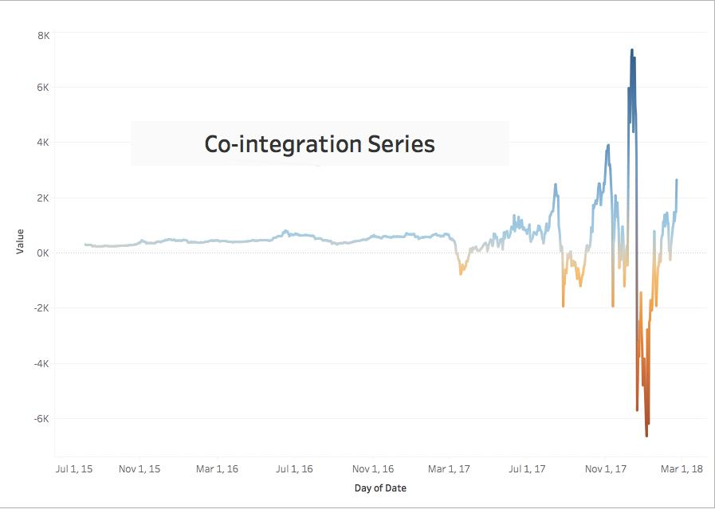

Volatility:

We calculated volatility for each of the cryptocurrencies by first finding returns and then estimating the volatility to be square of returns. Bitcoin, Dash and Litecoin displayed higher volatility than their counterparts – Ethereum, Ripple and Monero.

Below are the volatility graphs of each of the cryptocurrencies:
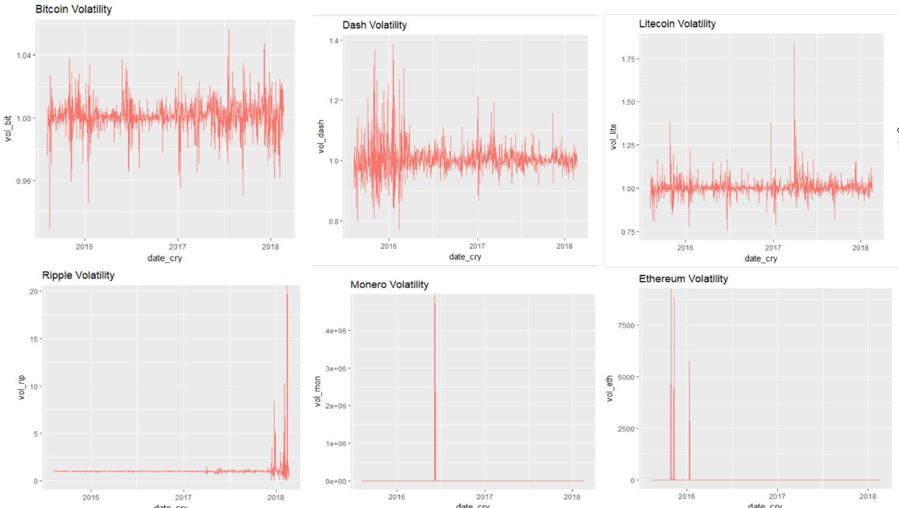
Omkar Mutreja

Ananya Bhupathipalli
Mohammed Farees Patel

FORECAST MODELS

We implemented two models to forecast time series - Linear Regression model and ARIMA model.

Since the cryptocurrency data is highly non-stationary and its market has changed considerably over the last year, we found it more appropriate to consider only the recent 8 months of data starting from “2017-07-06” till “2018-02-20”. The start date was determined based on the changing trends of the cryptocurrencies and July 2017 was deemed to be a good start date for training the forecast models.

We chose, Training data as “2017-07-06” till “2018-02-12” and Testing data as “2018-02-13” till “2018-02-20”

Regression Model:

We took “closing price” as the dependent variable and “lag(volatility)”, “log(volume)” as the predictor variables. This combination was chosen keeping in mind the fact that volatility and volume combined make great indicators of the stock market of a company.

Model: Closing Price ~ lag(volatility) + log(volume)
Below are accuracies obtained by predicting the closing prices of each of the cryptocurrencies using this model:

Bitcoin:

Ethereum:
Litecoin:
Dash:

Ripple:
Monero:

Forecast for Bitcoin using the above regression model:
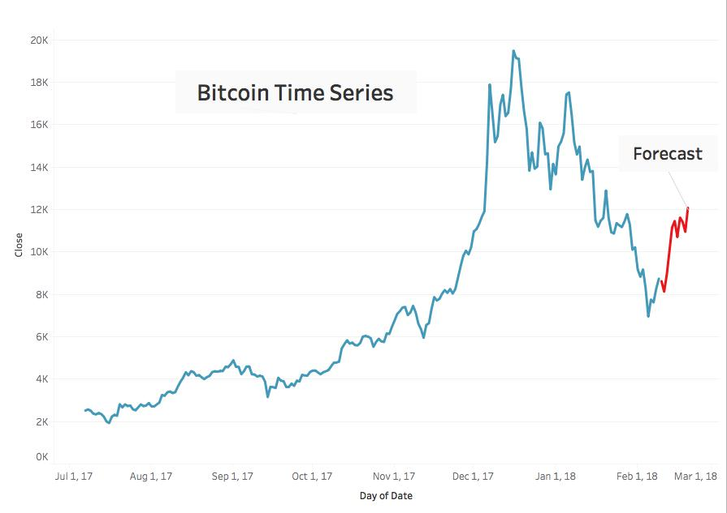
Omkar Mutreja

Ananya Bhupathipalli
Mohammed Farees Patel

ARIMA Model:

For ARIMA modeling, we used the same training and testing data as for the above model. First, we took the log of the closing price to transform the multiplicative series to additive series and observed its ACF and PACF graphs. We then differenced the log series, and obtained a model with no significant lags in ACF and PACF plots.
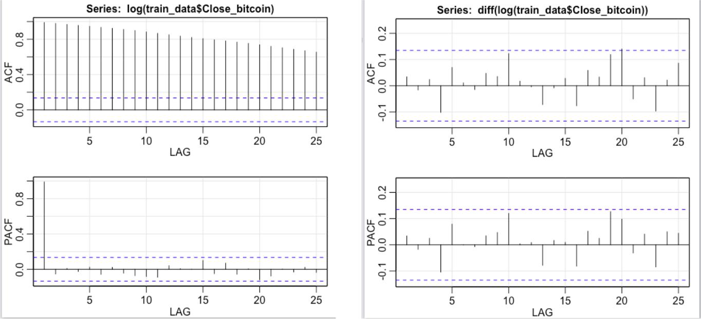

We then tried fitting different ARIMA model to obtain the best predictive model, and found that (0,1,0) model was the best fit.
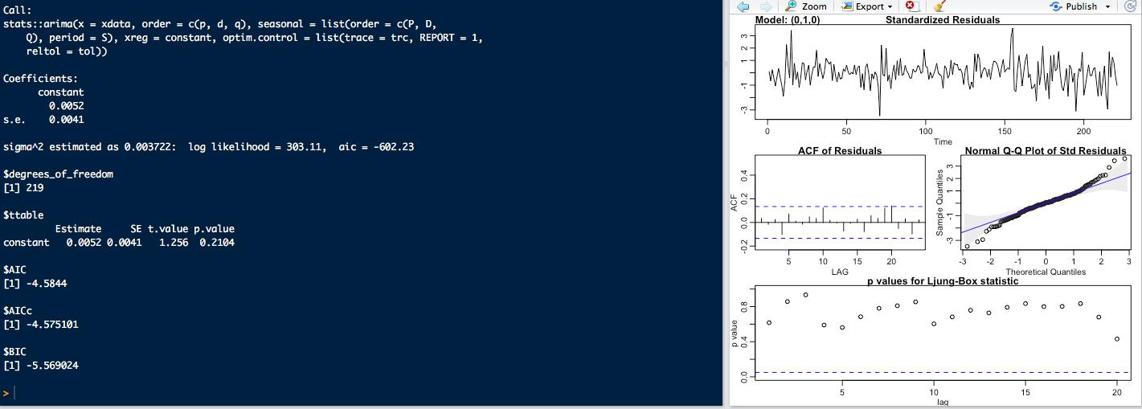
Omkar Mutreja

Ananya Bhupathipalli
Mohammed Farees Patel

Scope for Future Work

Cryptocurrency is a vast topic to explore and we have the following ideas that we can work on in future to further improve our analysis.

- Exploring the market factors effecting volatilities of the currency price, could make an interesting arena. Any significant factors that effect the volatility could be further used to model and forecast the price and market trends

- Another aspect could be to further understand how best we can utilize the co-integration series in combination with the forecast models to provide the best stock trading techniques

- As cryptocurrency is a very volatile currency, even minor changes can influence its prices. It would be worth investigating and collecting data about hacking, banning of ICO by China or negative news because these factors can have a significant impact on the trading price of the cryptocurrency. Incorporating these factors into the ARIMA or VAR model will help us capture most of the variances in the trading price

- Another, approach to forecast cryptocurrency prices is to explore how a few trendy ML approaches would perform. We can try to implement Random Forest or non-linear regression considering lagged values along with other features such as volume and volatility to predict the future values of cryptocurrency

